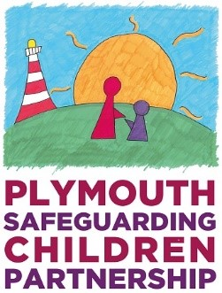

Safer Me Child In Need Meeting
Young person’s views

We want to make sure that your views and ideas are listened to at the meeting and that you are fully included in the discussions and plans for you.
You can come to your meeting and bring this form with you or give the form to your social worker, advocate or other trusted professional to bring for you.

What is your name and what do you like to be called?
How old are you?

Answering the following questions may help you to think about what you want to say.
- How much do you understand about why the Safer Me Child in Need meeting is happening?

- Do you know why people are worried about you? Can you explain?

- Is there anything or anyone that makes you feel upset or worried? You can write about it here or circle something in particular.
Friends | Where I live | School | Hobbies | Activities | Family | Someone on-line

- Is there anything or anyone at home that makes you feel upset or worried? You can write about it here or circle a person.
A parent | Step parent | Brother | Sister | Uncle
Aunt | Cousin | Friend | Grandparent | visitor

- What is important to you?

- Is there anything you want to change?

- What do you think is going well for you at the moment?

- Who helps and supports you best and what do they do that helps?

- Is there anyone else you can think of that can help and support you?

- If you are able to would you like to attend the meeting? Would you like to sit next to a particular person? Tell us who that is? Is there someone you don’t want to sit next to?

- You will be told about any decisions that are made at the conference, and this will be done in a way that helps you to understand what is happening next.

Please circle how you would like it shared with you and by whom.
Face to face | On the phone | By letter | other

Mum | Dad | Someone from  School | Social Worker | Chair of the meeting | Advocate | Other

