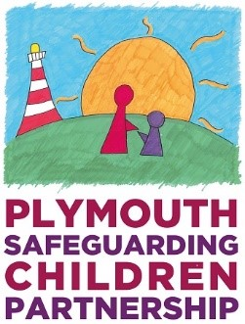
Child Protection and Safer Me Plus Child Protection Conference
Parent(s) / Carer(s) views
We want to make sure that your views and ideas are listened to at the conference and that you are fully included in the discussions and plans for your child/children.
Answering the following questions may help you to think about what you want to say:
Family Name: |  | Date of meeting:
Your Name and relationship to child: |  | Chair’s name:

1. Do you know why people are worried about your child(ren) at the moment? Can you explain?

2. Are you worried about your child(ren) at the moment? If so, what are you worried about?

3. Do you think anything needs to change to make things better for your child(ren)? If so, what might need to change?

4. What do you think is going well for you and your child(ren) at the moment?

5. Who helps and supports you with the care of your child(ren)?

6. What help or support do you think you need to help keep your child(ren) safe?

7. What can you do and can you think of anyone who can help you to provide this?

8. Is there anything else you want to say?

