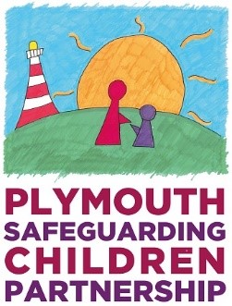

Child Protection/ Safer Me Plus Conference:
Parent/ Carer Feedback Form

Thank you so much for taking the time to fill in this form. We really want to know how it felt for you to come to the meeting and we need your good ideas to help us improve how we work with you and your family - and other families.
Please complete this and return to the Chair or email it to:
ASFHUB@Plymouth.gov.uk

(Child Protection Chair to complete this section ONLY with permission from the parent or carer)
Chair’s name: | (OPTIONAL)
District conference held in: | (OPTIONAL) |  | Date held: | (OPTIONAL)
Type of conference:  (Please tick) | ICPC  CP Review  Safer me Plus  Safer Me Plus Review |  | Family name: | (OPTIONAL)
 |  | (Parent or carer to complete the following sections)
- If this was an Initial Child Protection/ Safer me Plus Conference (i.e. the first meeting): Did the chairperson of the meeting telephone you before the meeting? |  | Yes No
If On a scale of 1 to 10, where 10 is the most helpful, please say how helpful this conversation was: |  | 0 1 2 3 4 5 6 7 8 9 10
Please tell us how this conversation helped you:
 |  | Agree Don’t Know Disagree
Th The social worker shared their report with me at least 3 days before the conference.
- Other agencies shared their report with me at least 3 days before the conference. If not please state which professionals did not.
- ……………………………………………..
………………………………………………
……………………………………………..
3. The chairperson of the meeting or the social worker explained to me what was going to happen and who was going to be at the meeting before it started.
4. I was able to let the conference know my views either by coming to the meeting or by having my views written down and taken to the meeting. I felt listened to.
- My ideas about what would help me, my family and children were included in the plan.
- I understand what needs to change/happen for the conference members to be able to consider ending the child protection plan.
For review/ Safer Me Plus conferences only
- The child protection/ Safer Me Plus plan helped my family achieve positive changes
What else would you like to tell us which might help us improve the experience of parents or carers at a child protection/ Safer Me Plus conference?

