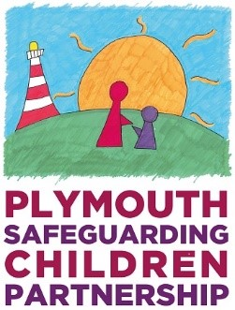
School Assessment

Pupil Development Needs
Health  (Of school population in relation to safeguarding) | Education  (Curriculum, PSHE, SRE in relation to safeguarding) | Emotional and Behavioural Development  (The moods and emotional regulation of pupils) | Identity and School Culture  (e.g. positive, normalisation, ethos of staff and students) | Peer Relationships  (Between students and staff to students) | Social Presentation  (e.g. of students to staff and outsiders)

Guardianship Capacity
Ensuring Safety  (Guardians are able to ensure students’ physical, emotional, and psychological wellbeing) | Trusted Relationships  (Students have relationships with adults whom they trust in the school) | Knowledge and Understanding of Safeguarding role  (Staff have training on safeguarding, are aware of safeguarding policy and procedures, and act upon this) | Policy Framework  (The school have appropriate policies in place to respond to safeguarding concerns that are used by staff and relate to those in use by the multi-agency partnership)

Environmental and Family Factors
Neighbourhood Safety  (Are students safe on their journey and around school? Is the school aware of issues locally and included in forums to discuss these?) | Parental Integration  (Are parents supported to engage with the school?) | Physical School Safety  (Do students feel safe in school? Is information collated on the location of incidents, etc.? Are there issues affecting the safety of students linked to the physical and online world?) | Resources  (Does the school have resources to respond to safeguarding issues? Do they engage with local partnership services, etc.) | Thresholds  (Are there clear thresholds internally for responding to safeguarding/behavioural issues? Are staff aware of these? Do these link to those used by the multi-agency partnership?)

