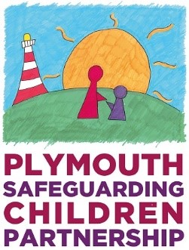

Peer Group Assessment Guidance

The Principles of the Peer Group Assessment

Introduction
Contextual Safeguarding (CS) is an approach to safeguarding that supports practitioners to recognise and respond to the harm young people experience outside of the home. Traditional child protection and safeguarding processes have predominately focussed on individual young people and their families. This Peer Group Assessment guidance has been developed by the Plymouth Safeguarding Children Partnership, based upon the Devon Children and Families Services model with the University of Bedfordshire, to support practitioners to consider and develop responses to assessing and working with peer relationships and peer groups. This guidance has been amended by Plymouth Safeguarding Children Partnership so that it can be used alongside their Adolescent Safety Framework and the Safer Me Assessment Tool.

Background
Research suggests that young people experience abuse from peers and are more likely to abuse others alongside peers (Barter, 2009; Firmin, 2017a; Gardner and Steinverg, 2005; Warr, 2002). As such, understanding the dynamics of peer groups is essential to developing safeguarding approaches that recognise and understand the contexts in which young people experience harm beyond the home. Current child-protection systems predominantly focus upon individual young people – from referral through to assessment, planning and intervention – and their family relationships. For example, social care assessments often feature a ‘genogram’ or family tree, detailing young people’s family relationships in order to assess safety, protective relationships, etc. While peer relationships may be acknowledged within individual assessments, in practice there are limited opportunities to explore and assess the nature of peer relationships and groups themselves (Firmin, 2017b). Peer group assessments provide opportunities for practitioners to consider:
- The dynamics of peer groups and the relationships between those who act as leaders and followers;
- The nature of relationships within groups, including the strength of association, loyalty and how the relationships came to be;
- The role of the peer group in influencing different types of behaviour displayed by individuals within the group;
- The relationship between the group and the contexts (schools, public spaces, family homes, online platforms, etc.) in which they spend their time.
Answering these types of questions provides a route to identifying effective interventions designed to work with peer groups, rather than just individuals within it.
This peer group assessment guidance includes two documents:
- Document 1: The principles of peer group assessments (principles document);
- Document 2: Peer group assessment practice guidance.

Document 1 outlines the principles of peer group assessments and is closely aligned to the advice and principles of carrying out a child and family assessment, as detailed within Working Together (2018). Document 2 details the process of carrying out a peer group assessment as developed by Plymouth Safeguarding Children Partnership. This document has been developed following reflections from practitioners from the Hackney Children and Families Service following the development of Peer Group Assessments, and has been by Plymouth.

Identifying and defining peer groups
Given the fluidity of young people’s relationships and the varying contexts in which they form friendships, it is important to consider the various ways that a peer group may be identified for the purposes of assessment. The first matter to note is that there is no singular definition of a peer group that could be applied in all cases. Rather, there are a range of ways that peer groups form and are identified, and a number of these are valid for peer assessment.
As noted by Kinderman and Gest (2018) and Veenstra, Dijkstra, and Kreager (2018), peer groups form due to:
- Relational ties – either young people who select to spend time with one another as friends, or young people who ‘hang-out’ together in particular contexts;
- Assigned ties – either young people who are identified as a group by others (e.g. in school this group of boys are always together and associated to, etc.), or young people who are together as a group by virtue of where they spend their time (e.g. they all attend the pupil referral unit together).
All of these groupings are valid. They just need to be distinguished when planning an assessment or intervention. If you are working with a group who have been identified as such because they are all in education together and, when they were there, they all bullied another student (but outside of school do not spend time together), then the intervention with them will need to engage with the dynamics of the school. Whereas if you are working with a group of young people who choose to spend time together (and this is not simply because they all happen to be in the same location together), then interventions will need to engage with these strong social ties that young people will likely want to protect.
It is important that workers remain reflective of who forms part of the group and are not limited by those included within a referral. It is important to ask stakeholders and young people who else may be included. To assist in this process, the assessing Social Worker may use tools such as peer group mapping. Guidance on peer group mapping can be found on the Contextual Safeguarding Network.

Legal considerations
When setting about conducting a Peer Group Assessment, and throughout the assessment process, the lead practitioner for the local authority must ensure that the exercise is legally compliant. Conducting a Peer Group Assessment is likely to involve an interference with Article 8(1) of the Human Rights Act – the right to private and family life – of all/some of the young people within the peer group. A local authority can interfere with this right, in line with Article 8(2) of the Human Rights Act, if mapping is conducted for the purposes of protecting a young person’s health and/or to assist the local authority in protecting the rights and freedoms of others affected by that peer group. However, in addition to ensuring this objective is met, the local authority needs to publish its policy on peer group assessment and mapping, clearly communicating to the public the conditions under which peer assessments may happen and the agreements that would need to be in place for assessment information to be shared with wider stakeholders (such as health or education services) who will be engaged to support members of the peer group following the assessment. Further arrangements will be required for the secure storage, retention and destruction of information held on Peer Group Assessments as well as agreements for the conditions under which parents must be notified (or not) when their children feature in a peer assessment exercise.
A full legal briefing ‘The legal and policy framework for Contextual Safeguarding approaches’ 2020 is available at CS-Legal-Briefing-2020-FINAL-1-1.pdf (contextualsafeguarding.org.uk)
For the purposes of this document however, it is important to note that:
- The primary objective for peer group assessments must be the protection of the health of the young people involved and/or the protection of the rights or freedoms of others who may be impacted by that group. Should mapping assessments stray beyond initial safeguarding objectives, they risk being non-compliant with legislation and policy.
- Throughout the assessment process, the lead practitioner should consult with their supervisor and wider policy team as to when parents of those featured in a peer group assessment should be notified.
- The information shared with stakeholders about the assessment findings must be confined to that which is required for the partnership to safeguard young people in the assessment in relation to the issues faced by the peer group. Information that is unrelated to this purpose cannot be shared.

The purpose of the Peer Group Assessment in the Safer Me Assessment
The Peer Group Assessment is included in the Safer Me Assessment.
The purpose of a Peer Group Assessment is:
- To gather important information about the peer group – to determine who are considered members of the group for the purpose of assessment, the strength of associations between members, and how they are known to each other (e.g. through an incident, a particular location or a period of time).
- To analyse their needs and/or the nature and level of any risk and harm being suffered by the group – are there particular contexts in which these needs or risks coalesce? How have these needs/risks been experienced historically?
- To provide support to address those needs to improve the peer groups outcomes to make them safe.
Young people’s peer groups and friendships are likely to change and develop over time. As such, assessments should be a dynamic process which recognise and respond to the changing nature of peer groups, including the changing risks posed to the peer group and the dynamics of the group itself.

A key part of the assessment process is understanding the makeup of the peer group itself and which young people are to be assessed. While a referral or concern may be made about a particular group, it is important for practitioners to consider who should be included within the assessment, or those who do not need to be included. It is important to listen to young people’s own perspectives on who forms their peer group and remain reflective in the reasons for why some young people may be referred over others. Peer group mapping can support this process (guidance on peer group mapping is available on the Contextual Safeguarding Network).
The local authority should have provision in place to deliver and support interventions to the peer group throughout the process of the assessment. If the assessment identifies needs or risks posed to individual members of the peer group (as opposed to the group as a whole) relating to a need or risk within the family, then an enquiry into MASH should made with recognition of the influence of the peer group within that.
While the primary purpose of the assessment is to identify risks and needs within the peer group, the assessment may identify needs or risks within a particular context itself, for example, a school or location such as a park. As such, the assessment and subsequent intervention plan should consider what further assessments may be required and which services are available to reduce risks posed within these locations.
If the assessment identifies needs or risks posed to individual members of the peer group (as opposed to the group as a whole) relating to a need or risk within the family, then the safeguarding processes still apply – an enquiry into MASH should made regarding those concerns, however, that enquiry should also include details about any peer group concerns as a risk which would also need to be considered within the safeguarding assessment.
A good assessment will require the co-operation and support of multi-agency partners throughout the assessment and intervention plan. While the assessing lead practitioner or social worker will hold overall responsibility for the management and coordination of the assessment and plan, they will need to work with other partner agencies, guardians and place managers to deliver the plan. In instances where needs or risks are located within particular contexts, it is important that the intervention plan works with those responsible for the location in the delivery of the plan.

The process of assessment
High-quality Peer Group Assessments:
- Are child-centred;
- Trauma informed
- Are rooted in child development, adolescent development, and research evidence on the nature of peer groups within the UK;
- Situate the behaviour, risks, vulnerabilities, and strengths within the peer group itself and the contexts in which they spend time;
- Outline actions and outcomes that are focussed on reducing risks and needs within the peer group and the wider contexts;
- Involve young people and families;
- Engage partners and agencies already working with the peer group; either those working with members of the peer group individually or the whole peer group;
- Work with those who can influence the behaviour of the peer group in relevant contexts;
- Build upon strengths;
- Develop and inform the design of intervention plans that attend to the needs and risks identified in different contexts as opposed to solely individual needs;
- Consider the risks, vulnerabilities and strengths within the group itself, and those of individuals;
- Are clear about the relationship and associations between the group without making assumptions about the nature of those relationships.

Assessment framework
When assessing peer groups, it is important to consider factors beyond those traditionally used in child and family assessment. Figure one below outlines the different elements that should be considered within a Peer Group Assessment. These fall across three domains:
- Group functioning – the dynamics of the peer group itself, how they relate to each other and their presentation to others.
- Guardianship capacity – the capacity, willingness and ability of guardians to keep the group safe. These will vary depending on the context in which the peer group is formed; for example, school staff or a local youth club.
- Environmental and family factors – which other factors affect the safety of the young people? These may relate to the local neighbourhood context, the policies in place to safeguard them, the support of their parents, or systemic factors.
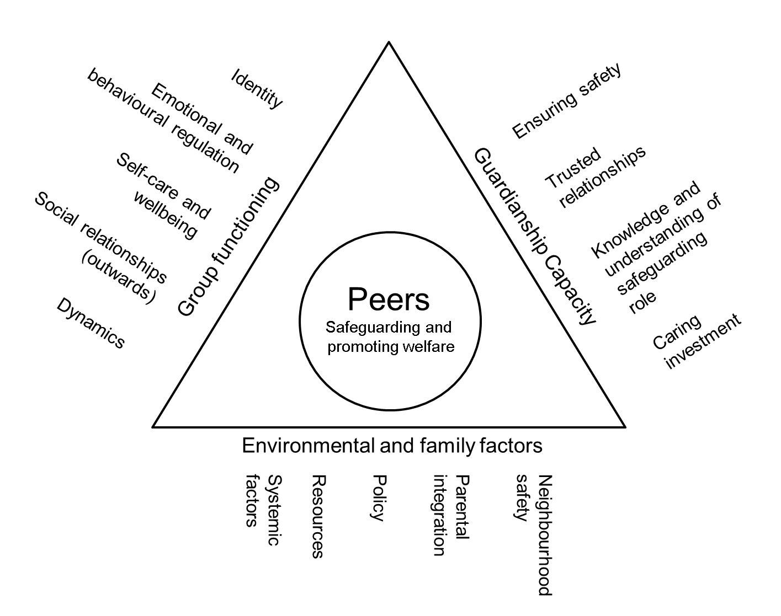
Figure 1: Peer Group Assessment Framework Focusing on the needs and views of the young people (Lloyd, Balci, Firmin and Owens, 2019).

Every assessment must be child-centred and recognise the voice of the peer group and individual members within it, including their perspectives on whom should be included within the assessment and the reasons for assessment. The assessment should, where possible, consider and acknowledge the views of parents/carers.
The assessment should bring together information from a range of professionals and, where relevant, information formed as part of other statutory or non-statutory individual assessments and plans for children within the peer group; for example, teachers, health professionals, social workers and the police.
Where relevant, the assessment and plan should align with or complement work already ongoing with individual young people or the interventions within the contexts they spend time in.

Analysis
As with child and family assessments, there is a need to identify the level of risk. Changes to the makeup of the peer group or associations with different young people or places should be considered and re-assessed, if relevant, in relation to the changing level of risk for the group.

Peer Group Assessment Guidance
Practice Guidance

Background
As part of the process of embedding Contextual Safeguarding within Hackney Children and Families Services, the Hackney Contextual Safeguarding project team have begun developing processes and approaches to working with peer groups. Through this work they are developing systems to support practitioners to carry out Peer Group Assessments – as opposed to individual child and family assessments used traditionally by social care. This Practice Guidance document outlines practical considerations when carrying out a peer assessment and a case study example. The guidance includes:
- Practical considerations
- A case study example of peer group referral
- Example session plans

Practical considerations
How peer group assessments are conducted will vary depending on the group itself, the nature of the referral, and how the peer group has been defined. For example, it may be that the group are defined as a peer group because they are a group of friends, were involved in an incident together, or by nature of attending the same school or area. Before beginning the process of the assessments, it is important to plan how you will conduct the assessment, including consideration of the makeup and associations of the group.

Peer group mapping

Peer group mapping supports practitioners to identify members of the group, the nature of associations of the group, and the parameters of what concerns the assessment will focus upon. Guidance on completing peer group mapping can be found on the Contextual Safeguarding Network. Peer group mapping may include engagement with stakeholders and reviews of case notes; these should be included within the assessment.

Parents

It is important to include parents within the assessment process. It is likely parental consent should be sought before beginning the assessment. Parents’ views about the peer group, their views on the harm, and ideas about interventions should be sought throughout the intervention. It may be appropriate to do this individually, within a group, or via another worker if the parents already have an established relationship with a practitioner.

Direct work with the peer group

When completing the Safer Me Assessment, it is important to speak directly with the young people and in some circumstances the group themselves. However, it is acknowledged that it may not be possible, safe or appropriate to do so at this stage.

For a Safer Me Assessment to successfully understand the risks, young people and the peer group will need to have a voice in the assessment process. If the young people have not already been involved, when planning the Peer Group Conference, we will consider how to involve them and their parents/carers in this process (including whether it is appropriate to invite them to attend the Peer Group Conference) and how they will be included in any future decision making/actions.

Direct engagement with the group should be appropriately planned, including consideration of risks associated to bringing the group together. It is important to ask partner agencies and the young people themselves if it would be appropriate to bring the group together. If it is not, then it may be necessary to complete direct work in smaller groups.

The purpose of the assessment is to consider the risk, vulnerability and safety factors facing the peer group, and the dynamics of the group itself.

Table 1 below provides some example questions to consider when developing a peer assessment. These questions relate to the Safer Me Assessment. These are not prescriptive but can be used as a guide to develop direct work with young people and may help to inform the assessment.

Table 1: Peer assessment questions

Group functioning | Identity | How they view themselves  - Would you say you are a ‘group’? Or something else?  - How long have you been ‘together’?  - What things do you have in common?  - Tell me about how you became friends and a group?  - If your group was an animal, what sort of animal would it be?  - What are some of the good things about your group?  - If you were asked the same questions on another day, would your answers be the same?
 | Emotional and behavioural regulation | The moods and emotional regulation of the group  - What happens when someone is upset in your group?  - If you think about the sort of moods a person has (ask for responses)…what kind of moods are in your group – for example, is it mostly joking and fun, mostly serious talk, mostly worried talk?
 | Self-care and wellbeing | How the group looks after itself  - How often do you see each other? How much, and in what ways, are you in contact with each other online?  - Do you sometimes need a break from each other? What happens then?  - What happens when you fall out?  - If you could change something about your group, what would it be?  - What would you say you are best at as a group of friends? What are your best qualities?
 | Social relationships (outwards) | How they are perceived by others  - How do others (teachers/other groups/parents/shop keepers) see you?  - Behave towards you?  - How do they treat you?  - Are you part of other groups too? What is the relationship between this one and other groups you’re in?
 | Dynamics | The inter-personal dynamics in the group  Preamble – we know people play different roles in

groups. What do we mean by ‘roles’? What kinds of roles can you have? (Might need to give them some examples – leader, follower, joker, helper, etc.).

One option – suggest taking one of the words, e.g. leader, and ask group to silently place themselves in line with the person who is most often the leader at this end and the person who is least often the leader at the other end. It’s important to talk a lot about how groups need different sorts of people in them, so it’s not better or worse to be the ‘most’ or ‘least’ in any way.

Another option – ask them to record privately on a post it, the roles people can have or the role they have.

Discussion questions if this seems better:

- Who tends to decide what you do together?
- Would you say you have a ‘leader’?
- What other ‘roles’ do you have?
- Who is the bossiest person in your group?

Guardian  capacity  Identified guardians with responsibility  for a context | Ensuring safety | - Are all the spaces where the group spends time safe?  - Do guardians and those with responsibility for the context ensure safety?  - If not, do they have the capacity to do so?
 | Caring investment | - Are there trusted adults around the group (other than parents)?  - Is there parental oversight of the group (i.e. to what extent do they have a relationship with group members, know them, are in contact with their parents, show an interest in the group’s activity and well-being, etc.)?
 | Knowledge and understanding of  SG role | - Are guardians aware of their responsibility for safeguarding in this context?  - How are guardians responding to harm (e.g. online provider reporting monitoring illegal activity; parents reporting to police if missing; professionals making referrals)?
Structural issues | Resources | - What is available in the community for this group to access?  - What do they access?  - What are the barriers and enablers of accessing community resources?
 | Neighbourhood safety | - Where does the group spend time?  - What times of day are they there? Who else is there?  - What is the impact of the location upon their safety – consider physical environment (e.g. impact of the park)?
 | Systemic factors | - What is it like for you growing up in [area name] / [neighbourhood name]?  - What is the group’s experience of discrimination(e.g. impact of harmful gender norms or racism)?
 |  | - Are there any issues with the history of individuals in the group or in the groups’ experience that are relevant to the current assessed harm (e.g. intimate partner violence at home, migration, being looked after, etc.)?
 | Policy framework | - What is the procedure framework (legislation, policy, guidance) relevant to the safeguarding of this group?
 |  | - Is policy supportive of safety?
 |  | - Are there gaps?
 | Parental integration | - Do the parents of the group know each other?  - Are the parents integrated in the contexts the group spend time?

Visit www.contextualsafeguarding.org.uk for more information.

