Peer group mapping guidance

Part One: Peer-mapping process
Part Two: practical guidance for practitioners

Peer group mapping guidance:

Background
Contextual Safeguarding (CS) is an approach to safeguarding that supports practitioners to recognise and respond to the harm that young people experience outside of the home. This peer group mapping toolkit has been developed by the Hackney Children and Families Services’ (HCFS) Contextual Safeguarding Team to provide guidance to practitioners in understanding when it might be suitable to undertake peer mapping exercises, and how this process can be used to more effectively implement and manage safeguarding interventions. This includes gathering and mapping the correct information in order to determine whether a peer group assessment is required or not.
Young people can encounter both risks and safety within their peer networks and social circles, as well as in locations outside of their home. Through carrying out peer mapping exercises, practitioners can identify and understand the nature and extent of these. Peer mapping achieves this by:
- Providing a detailed picture of the roles and relationships between individuals, including the amount of influence and control individuals have within a network.
- Giving an understanding of the nature, scale and seriousness of the vulnerabilities posed by/to identified peer groups, individuals and locations.
- Supporting the identification of effective safeguarding interventions and other suitable multi-agency opportunities (e.g. disruption, environmental change).
- Focusing awareness on information gaps, and how to inform these by information gathering.
- Providing a foundation for the ongoing management of the peer group/location within a multi-agency partnership context.
This guidance is separated into two parts:
Part one – explores the rationale for undertaking peer group mapping, identifies useful steps to consider both before and during the mapping sessions, and information on defining/managing actions for further work.
Part two – outlines the practical steps for carrying out peer group mapping with exercises to support this.
This guidance should be used in conjunction with existing Children and Families Information Sharing Protocols and multi-agency partnership information sharing protocols *(An information Sharing Protocol in relation to peer group information recording currently under development)

Part One: Rational, parameters and mapping sessions

Starting a Peer Mapping Exercise
Rationale
When starting a peer mapping exercise, consideration should be given to its purpose. Although a peer map showing connections between young people might appear useful, the end product might be limited in terms of helping practitioners understand and manage the vulnerabilities and issues identified.
There are a number of benefits to peer group mapping, for example:
- Identifying key issues linked to the young people who are being mapped: Peer mapping may help practitioners identify key themes (e.g. county lines, gang exploitation) or vulnerabilities (e.g. substance misuse, mental health concerns) linked to the young people/locations being mapped. This might highlight recent incidents/events of concern that may have affected the group or specific contexts associated with the young people (e.g. recurrent schools or parks). Mapping can also identify positive elements in the group that can be strengthened/used during intervention.

- Identifying what information is missing/still needed: Peer mapping may identify gaps in information, for example, if there are young people/locations outside of Hackney – what isn’t known about these people or areas? Are there gaps in information and can partner agencies (e.g. police, school) fill in the gaps? Are there characteristics about a location that links the young people that needs exploring further? Are there historic but thematically relevant incidents (e.g. when mapping a school network linked to image sharing, have previous incidents been recorded as occurring at the same school)?

- Managing the mapped network: When reviewing an existing peer group, are the relationships between young people/locations still current? What safeguarding interventions can be applied to each issue, and which agencies are in the best place to deliver these? Have information gaps been addressed and have these identified any further issues? Have clear and accountable actions been identified from the mapping process?

There are likely to be reasons that a practitioner may decide to do a peer group map and therefore mapping may take place at different points. For example, a peer group not previously known to services may be referred into Children’s Social Care in the aftermath of a significant incident taking place. Or if a group of young people, already open to children’s services, are involved in an event that highlights the need for some peer mapping to take place. This could be a combination of known and unknown children who are open to a variety of professional agencies. Different levels of information will be held on the individuals on a case by case basis.

Pre-Mapping Work
Peer mapping is a multi-stage process – a tool to be used to develop and shape practitioners understanding and responses to a specific problem. The process also provides a structure to challenge and reflect upon existing perceptions of each identified problem – are the young people initially identified really key parts of a vulnerable peer network? Has a high-profile incident really influenced the peer group?

Therefore, before holding an initial mapping session, it is beneficial to identify what you believe the key issues and vulnerabilities are, based on all available information. This might come from a Police Merlin report relating to a group-based incident, the initial referrer (person referring the case into FAST (or the local safeguarding hub) or it might come from repeated conversations with other practitioners concerning the same location or cohort of young people.
Questions to consider at this stage might be:
- Have you identified a list of persons linked to the issue/peer group/location of concern?
- Are there any environmental contexts (e.g. school / neighbourhood locations) highlighted by the information?
- Have key contacts in relation to these young people and contexts (e.g. practitioners, youth workers, school safeguarding leads, police officers, housing wardens) been identified?
- Are there any contexts/young people identified who are already subject to contextual safeguarding/peer mapping?
- Have key questions been identified in relation to each young person/context/vulnerability as to how they relate to the network being mapped?
It may be beneficial to organise your notes into a matrix or spreadsheet (Figure 1)

Figure one: information to consider

Current concerns - vulnerabilities | Missing episodes – believed to be going to Plymouth with drugs/links to grooming for county lines.  Substance misuse – cannabis  Currently NEET
Current linked contexts | 123 City Road(adult male address where male A stays during missing episodes)  Plymouth house where Male A was arrested for PWITS Positive context – attends youth hub
Linked peers/ peer group | Unknown adult male (1232 City Road)  Male B – positive relationship from previous school Male C – found in Plymouth  Female A – girlfriend (believe positive)  Female B – Vulnerable YP in Plymouth
Key contacts | Police Contact – Plymouth Youth Hub staff member  Substance misuse worker Police contact - Misper
Key questions | Who is the adult living at 123 City Road? Who else is linked to 123 City Road  What is the address in Plymouth and have any other arrests been made?  What is the relationship with female in Plymouth?  Is the relationship with Male B and Female A still positive?  So does the risk change if it is online?

Mapping Sessions
The peer mapping meetings are not intended to replace Strategy Meetings or other planning meetings, but should inform and direct the safeguarding and planning processes in a more contextual way.
When holding a peer mapping meeting, it is important to remain focused on the original objectives of the process. A lot of information will be shared and obtained, particularly when discussing larger peer groups or thematic issues, and it is therefore important that the structure of the meetings enables reflection on which information should be included in the map. Focusing on the information relating to the issue being mapped will prevent tangents into unrelated areas of vulnerability (which may warrant a separate mapping exercise), and ensure interventions don’t become too broad and ineffective as a result.
The peer mapping process should be undertaken over a number of sessions, with the initial one(s) focusing on internal information sharing and mapping (e.g. between Children and Families Services practitioners). This will give relevant partner agencies the time needed to collate relevant information on the children/young people and the locations being mapped which can then be brought together at a follow up session or planning meeting. This method will also assist in keeping the network map up-to-date, through regular revisiting of information gaps, actions and interventions during the period of work. Please see section two of this document for detailed information on the process of peer-group mapping.
Once peer mapping has been completed, considerations should be made towards the identified risks or strengths of the group. The Hackney Wellbeing Framework and context threshold document can be used to support with this thinking. If clear links are identified between young people following peer mapping, and the risks are significant, then a peer assessment should be undertaken. Guidance on undertaking peer assessments can be found on the Contextual Safeguarding Network.
Equally, if concerns identified following peer mapping relate to a location or highlight concerns about a particular school or an organisation (and threshold is met) then context assessments should also be undertaken.

A peer mapping process should look like this:

Figure two: Peer Mapping Process
Peer Mapping  Session #1  Internal |  | - Internal Teams (e.g. Plymouth CSC, Youth Work, Plymouth AST)  - Identify and map information to shape peer/context map  - Review current map and update where needed  - Identify information gaps  - Identify key partners to inform these gaps
Peer Mapping  Session #2  Inc. External |  | - Include external partners identified from session#1, e.g. police, school staff, health, third sector, housing, licensing, PARC etc.  - Identify and map information to shape peer/context map  - Review current map and update where needed  - Identify information gaps/safeguarding interventions  - Identify actions to inform gaps and enable interventions
Review Peer Mapping Session |  | - Review existing actions  - Review current map and update where needed  - Identify information gaps/safeguarding interventions  - ‘Close’ peer group work when work has concluded.

The initial peer mapping session should take place within two weeks of the identification of a contextual issue/risk (e.g. a Police report concerning a group-based incident, or a school raising concern about the culture of a classroom), with the first mapping meeting involving external agencies taking place within two weeks of the initial meeting.
It is important that those invited to the mapping sessions have enough time to research and collate information on the subjects/contexts being mapped. Sending a summary or list of subjects through secure email at least one week before the planned session should provide enough time for this research to take place.
Once a peer mapping meeting has been held, minutes and any other documentation produced (e.g. a physical/digital peer network map) should be uploaded on the Mosaic file of all key subjects within two weeks of the meeting. The title of these uploaded documents should clearly state the key contextual risks of the network (e.g. Peer Mapping Minutes Peer Network – County Line to Plymouth; Peer Mapping Minutes Peer Network – Image Sharing Primary School).

Review mapping meetings
Review meetings should take place following a significant incident taking place or an important piece of information being shared, or otherwise when an intervention has concluded. At the end of each mapping session, clear actions should be identified for obtaining further information (where this is needed) and the implementation of safeguarding

interventions, and the timescales for these should help the setting of a date for the review meeting. Dependent upon the level of update to the peer network map, the review can take place with multi-agency partners within an existing review meeting.
When a review meeting is held, updates should be sought for all outstanding actions, and each mapped subject and context should be reassessed. The latter is important in ensuring that resources and interventions are being applied to the right parts of the mapped network, and that those who are no longer part of it are removed (as well as new subjects being added). Review meetings should continue to be held until there is agreement that the risks and vulnerabilities linked to the subjects/contexts have reduced.

Part Two: Peer Group Mapping Practical Steps

This document outlines the practical steps for mapping a peer group. The process of mapping will vary between groups/ incidents; the following provides guidance of key practical steps that can be used.

Pre-meeting process

Prior to holding a meeting/discussion with practitioners to map out peer relationships the following considerations should be made:

Peer group mapping with a young person

- Wherever possible, a peer group mapping exercise should first be carried out with each of the individual young people in the group that has been referred. The aim is to find out their view of their peer group and the group dynamics; this information will inform the professionals meeting or, if it is done at a later stage, can be used to test out the information provided by professionals. The worker with the best relationship with the young person should do this. (See Appendix B for a suggested exercise to use with young people.)

Pre-meeting gathering of information

- Gather the information that is already available on each young person from case management systems, if they are open to services. Find out which professionals/services are working with them. If they are not open to services, are there other key stakeholders who know them or have worked with them, e.g. Voluntary and Community Sector organisations? Consider, during the direct conversation with the young person, if they have mentioned any other friends/peers who should be included?

Peer group mapping meeting

For the actual peer mapping exercise, it would be advisable to prepare yourself with flipchart paper, coloured pens/markers and post-it notepads (in case you need to stick these on top of names of locations or overlay information).

- Conduct a peer group mapping meeting with the key professionals and stakeholders linked to the group to ensure a systematic approach to gathering information. Where there are information gaps, task people with finding out more information with a clear deadline in mind.

- When peer mapping, remember to test out the strength of relationships; whether information is evidenced or if it is just anecdotal; how many times have the young people been seen together, where have they been sighted and by whom? When was this information captured – is it a recent or historic incident? Where does the information come from? Is it a reliable source of information? Who are followers/leaders in the group? Are there protective features about the group or are they solely negative/risky?

- Record the information – you can create a map however you want as long as it is legible, presentable and can somehow be recorded/captured on the information management system. Taking a photo of a clearly drawn map is fine. See Figure 3 below for an example.

- Once you have gathered all your information, redraw the map removing any excess details and writing them up as a separate narrative. This helps to keep the map clear while not losing important details.

- Ensure that the peer map is dated and that you build an appropriate review timeframe into the meeting process – e.g. every 3 months but also when there has been a significant development or incident which impacts on the peer group/relationship.

Suggestion: why not practice creating a peer map with a case that is already open by mapping and testing out their peer group connections?

Figure 3: Example peer group map
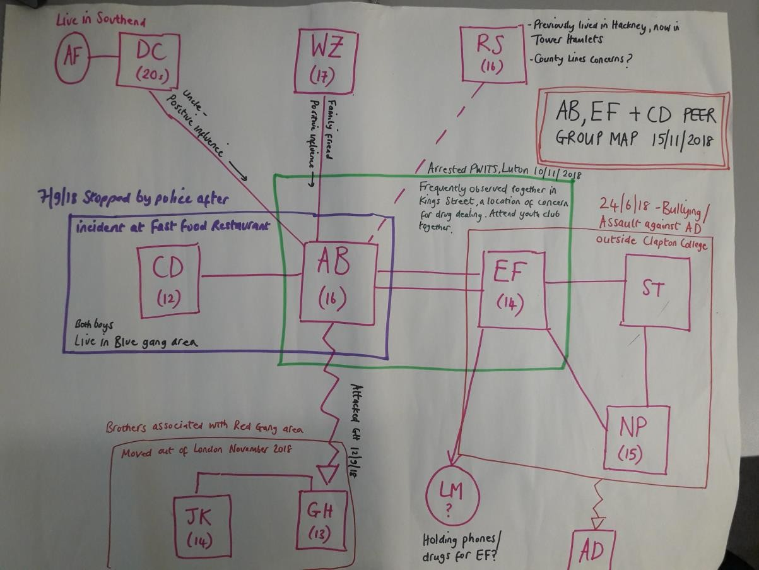

Appendix B: Peer Group Map Exercise for direct work with young person

You will need: A4 or A3 paper and pen or coloured pens
Step 1: Ask the young person to draw a circle at the centre of the page that represents them.
Step 2: Ask the young person to draw their friends or other young people they socialise with (their peers) on the paper around their circle. They should place them closer to, or further away from, their original circle depending on how close or distant their relationship is. See the example below:
Friend A
Friend B
Best friend
Me
Friend C
Cousin A
Cousin B
See my cousins at the weekend.
Know C from football, mostly see him at practice & matches
Known best friend since primary school. Used to live on same estate. Mums know each other.
Used to be good friends with A and his brother B. Knew them from school but they have moved out of the area.

Step 3: Use the map to explore the peer group dynamics with the young person. Ask questions about their friendships; find out more about the dynamics of their relationship, including any positive or negative influences. Examples of questions include:
- Who are you closest to?
- Who do you spend most time with?
- Who would you say is a positive influence on you?
- Are you a positive influence on someone?
- Out of all your friends, who would you trust to help you if you were in trouble?
- Out of this group, are there any friends that your parent/carer/teacher would say has a negative influence on you?
- Do you think you have influence over anyone?
- Are you friends’ parents/carers happy for you to spend time together?
- Do your parents/carers know your friends or their parents/carers?

- Have you ever got into trouble (at school, with the police, at youth club, etc.) with any of your friends?

As well as being an information gathering tool, this exercise can form an intervention tool with an individual, by including an additional step 4:

Step 4: With the young person, think through strategies that will support them to build on the strengths in their peer group and to reduce the harm. For example, if the exercise has demonstrated that loyalty to a particular friend or group is causing young people to get into trouble with the police or teachers, are there ways that the young person can maintain that loyalty and friendship without engaging in negative activities? E.g. putting an agreement into place with their education establishment or their youth club for them to leave at a different time from their peers.

