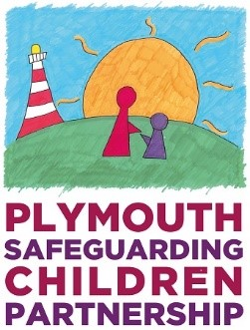

Safer Me / Safer Me Plus Agenda

1. INTRODUCTION
- Introductions & Apologies
- Chair’s Welcome

2. ECOMAP

3. INFORMATION SHARING
- Reason for/purpose of meeting – the nature of the context itself and the impact it has on the welfare of the young person. This is based on the Safer Me Assessment and mapping (and neighbourhood meeting and peer group meeting if applicable).
- Events since the last Safer Me Plus meeting and update on plan from lead professional. REVIEW ONLY
- Voice of the child/children – what they are worried about, what’s going well and the impact on them. To include the young person describing the context of how they see the world, their own life and what they believe would make them feel or be safe(r).
- Parent’s view of what they are worried about, what is going well and the impact on the child. To include parents describing the context in which they are trying to parent their young person (both the positive and challenging aspects of that context).
- Views of professionals – what they are worried about, what is going well and the impact on the child. To include the professionals describing the context in which they are trying to keep the young person safe.

4. THE PLAN: An intervention plan which is clearly targeted at the context in which the harm takes place

- Chair’s clarification of What Safe Will Look Like/What we are trying to achieve.
- Clarification of by who and when.

5. CONTINGENCY PLANNING: when the plan is not progressing and the risk of harm is increasing
- What would tell the family and professionals that this plan isn’t working? What would an increase in danger look like?
- Who would look after the child if one or both parents could not?

6. CHAIRPERSON’S SUMMARY
- A summary which identifies:
  - Pre-existing vulnerabilities and risk factors that combine within a context to cause harm (and the impact on the young person);
  - Mitigating protective factors that combine within a context to reduce harm (and impact on the young person).
  - A summary of the outcomes (what we are trying to get to).

7. DECISION MAKING
- Views of young person
- Views of parents
- Any dissenting views

8. IF THE CHILD/CHILDREN ARE PLACED OR ARE TO REMAIN SUBJECT TO A SAFER ME PLUS PLAN
- Multi-agency decision with rationale from the chair.
- Date and time of review meeting agreed.
- Confirm members of Safer Me Plus core group and date of next core group meeting.
- Confirm how the parents (including absent parents) and children are going to receive the minutes and plan and attend/participate at the next meeting, e.g. advocacy/ split meeting.

CORE GROUPS and SAFER ME PLUS MEETINGS
- As agenda above from points 1-6 inclusive.
- Review the progress of the Family Plan.
- Rescale.
- Review contingency plan.

